GROUP 10

INVENTION MANAGEMENT SYSTEM

The Invention Management System Database is made to store

* Invention details
* Inventor details
* Awards Received etc.

This Use Case Diagram depicts the High-level view of the Invention Management system.

It also provides the scenarios in which the application interacts with,

* Inventor
* Jury
* Admin

|  |  |
| --- | --- |
| **Actor Category** | **Actor** |
| Primary Actor | Jury, Admin |
| Secondary Actor | Inventor |

There are total of Twenty-Six use cases that represent the specific functionality of Invention Management System.

Each actor interacts with a particular use case.

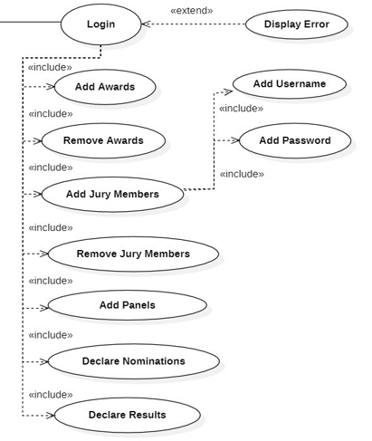

**Functionality of Admin:**

* Login to take the overall Control of the Data Base
* Add or Remove Awards
* Add or Remove Panel
* Add or Remove Jury
* Declare Nominations
* Declare Results
* Admin takes the overall control of the database or in other words say one of the primary Actors.
* Admin have to just login inside the database and gets the overall control.

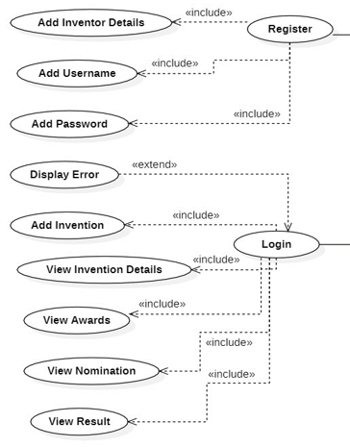

**Functionality of Inventor Actor:**

* Register in the database to create Account
* Register for New Username and Password
* Login using his/her credentials
* Add the details of his/her invention
* View the Invention details
* View Awards
* View Nominations
* View Results
* Inventor can create the account in the database to register his/her invention.
* Once registered Inventor needs to set the username and password to login into the database next time.
* Once Inventor Actor successfully logins, gets option to add the invention to the database.
* If Inventor is not able to login successfully then, they will get the Error message.
* Inventor can also view the invention details that he/she have enclosed while registering in the database.
* Inventor can view the results of the invention.

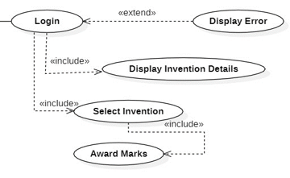

**Functionality of Jury Actor**

* Login to Invention Management System
* View Invention Details that are Displayed when logged In.
* Select the Invention
* Award Marks for the Selected Invention.
* Jury can login to the Invention management system using the credentials provided by the Admin.
* Once they successfully login inside the Portal they get access to all invention.
* If they are not able to login successfully then they will get the Error message.
* From the list of inventions given they can select the allotted invention.
* They can look into the inventions and award marks to the selected Invention.

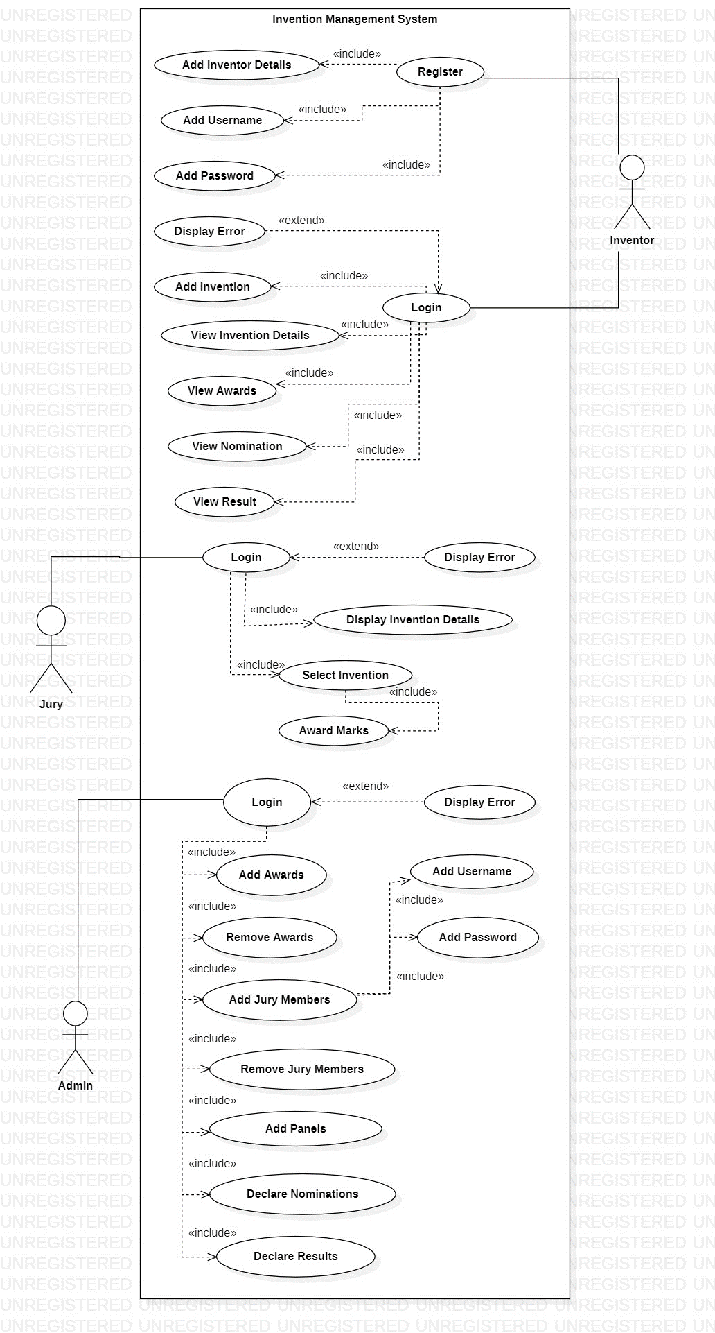

**Done By,**

* S. Abhishek - AM.EN.U4CSE19147
* Rahan Manoj – AM.EN.U4CSE19144
* Harsha Sathish – AM.EN.U4CSE19123
* Arvind Kumar K – AM.EN.U4CSE19109

**THANKYOU!!!**